# RAG MODULE

## 5.3. In-Context Learning

In this video, you'll be introduced to the concept of in-context learning through prompts. Anup explains how this form of learning is scalable, particularly when dealing with vast amounts of data.

This becomes especially relevant when we recall our earlier discussions on Retrieval Augmented Generation (RAG). Understanding in-context learning amplifies the efficacy of technologies like RAG in Large Language Models.

YouTube Video to be Embedded: <https://youtu.be/OXZQBXBvOR4?t=284>

## 

## 5.4. High level LLM Architecture Components for In-context Learning

In this brief video, Anup provides a high-level breakdown of how in-context learning operates within an LLM. He'll guide you through the journey of a prompt as it interacts with a vector database or index, undergoes similarity search, feeds context, and eventually results in a coherent LLM output.

Understanding this architecturAe is essential for mastering the interaction between prompts and LLMs, a crucial skill for anyone looking to effectively deploy these models in a variety of settings.

YouTube Video to be Embedded: <https://youtu.be/OXZQBXBvOR4?t=595>

As you may have noticed, the concepts explained under 'in-context learning' in the forthcoming sections are essentially what RAG accomplishes. In-context learning allows your LLM to adapt and respond based on not just the pre-trained data, but also from the external, real-time information it retrieves. This is precisely what RAG is designed to do.

### 

## 5.5. Diving Deeper: LLM Architecture Components

In the forthcoming video, we provide a detailed explanation of the essential components that constitute a Large Language Model's architecture. This video aims to extend your comprehension of the LLM architecture, contributing to your foundational understanding of the field.

### In this video, we've learned about

* The User Interface Component designed to pose questions
* The Storage Layer, which utilizes Vector DB or Vector Indexes
* The Service, Chain, or Pipeline Layer, which is instrumental in the model's functioning (with a brief mention of the Chain Library used for chaining prompts)
* Summary of our learnings around LLM Architecture Components

Let's look at a cleaner architecture diagram, and various steps of the pipeline and summarize the advantages of RAG based on what we've understood so far.

​

YouTube Video to be Embedded: <https://youtu.be/OXZQBXBvOR4?t=704>

## 5.6. LLM Architecture Diagram and Various Steps

Now that we've explored the various components that make up the architecture of Large Language Models (LLMs), let's dive into how Retrieval-Augmented Generation (RAG) can work synergistically with these components of an LLM architecture. The aim is to show you how RAG can supercharge an LLM's capabilities by seamlessly integrating real-time or static data sources into the information retrieval and generation processes.

## 

## **LLM Architecture**

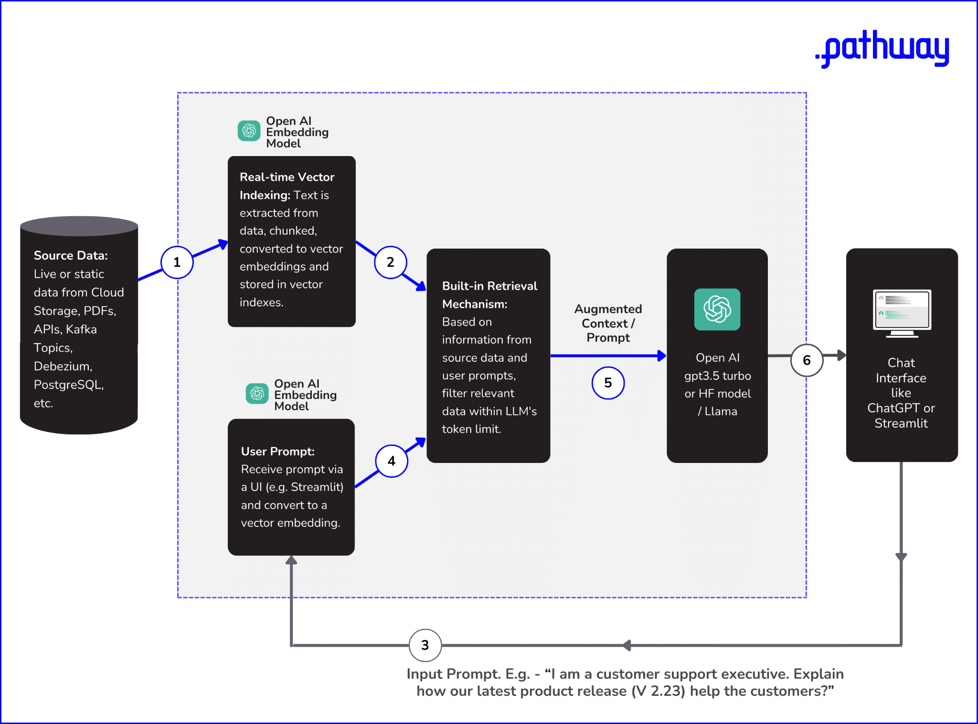

[LLM Architecture Diagram to show how RAG works with Real-time or Static Data Sources](https://drive.google.com/file/d/13MJhLUa7Nvtj7YZh1gXWVqMUT96iWF76/view?usp=sharing)

For a nuanced understanding of how Retrieval-Augmented Generation (RAG) optimizes Large Language Models, we'll delve into the essential elements and procedural steps that comprise the LLM architecture.

1. **Data Sources**: Whether your starting point is cloud storage, Git repositories, or databases like PostgreSQL, the first task is to bring these varied data forms together through pre-configured connectors.
2. **Dynamic Vector Indexing**: Text from these data sources is broken down into smaller segments (also called "chunks") and converted into vector representations. Models specialized for text embeddings, such as OpenAI's text-embedding-ada-002, are employed here. These vectors are continuously indexed to facilitate rapid search later on.
3. **Query Transformation**: A user’s input query is likewise transformed into a compatible vector representation, ensuring that it can be effectively matched with the indexed vectors for data retrieval.
4. **Contextual Retrieval**: Algorithms like Locality-Sensitive Hashing (LSH) are applied to find the closest matches between the user query and the indexed data vectors, staying within the model's token limitations.
5. **Text Generation**: With the retrieved context, foundational LLMs like GPT-3.5 Turbo or Llama-2 employ techniques from the Transformer architecture, such as self-attention, to generate an appropriate response.
6. **User Interface**: Finally, the generated text is presented to the user via interfaces like Streamlit or ChatGPT.

# 

## 5.7. RAG versus Fine-Tuning and Prompt Engineering

In the rapidly evolving landscape of Large Language Models (LLMs), achieving cost-efficiency and operational simplicity is critical, and this is where Retrieval-Augmented Generation (RAG) shines. When compared to methods like Fine-tuning and Prompt engineering, RAG stands out due to its advantages in cost-effectiveness, simplicity, and adaptability.

Let's individually explore these options to understand where RAG excels.

### 1. Fine Tuning Vs RAG

For those less familiar with the concept, fine-tuning involves modifying a pre-trained language model (such as GPT-3.5 Turbo, Mistral-7b, or Llama-2) with a smaller, targeted dataset to work optimally for specific use cases.

While fine-tuning avoids the need to build a model from scratch, it does have its drawbacks, which RAG effectively addresses.

#### **Data Preparation Challenges**

* Having control over training data permits steps to address biases, yet implementing such measures is far from straightforward. Interventions like altering variable importance or ensuring balanced data distribution demand in-depth data analysis skills.
* Furthermore, expertise in the subject matter is essential for accurately annotating data that serves specialized or research-specific functions.

#### **Cost Efficiency**

* Retraining and deployment are not only time-consuming but also financially taxing.
* For instance, the use of vector embeddings API in RAG models is roughly **80 times** less expensive compared to commonly utilized fine-tuning APIs from OpenAI.
* Consider the need to repeat this process each time your company launches a new product, all to ensure that your teams are not provided with outdated information from your Gen AI model.

#### **Data Freshness**

* At the outset, it's only logical to expect that when developing an LLM application, you'd want your large language model to consistently deliver current and pertinent out.
* When it comes to fine-tuning, the model's accuracy can significantly decline if the data undergoes changes or isn't regularly updated. Consequently, despite the associated challenges, this task must be performed at frequent intervals to maintain the model's efficacy.

Hence in practical scenarios, for performance-related reasons, if certain developers or companies use fine-tuned models instead of general foundational models such as GPT-4, they often use those models with an RAG-based architecture itself.

### 

### 2. Prompt Engineering vs RAG

Prompt engineering might seem like a lighter alternative but comes with its own set of challenges, such as data privacy, inefficient retrieval of information, and the technical constraint of a token limit.

* **Data Privacy**: For organizations handling sensitive information, the act of manually copy-pasting large chunks of data to retrieve a specific piece poses a risk of unintended data exposure.
* **Inefficient Retrieval**: When dealing with vast data corpora, knowing where to find the relevant data becomes crucial. Manual prompt engineering lacks the efficiency offered by automated mechanisms, such as vector indexing in RAG, which enables quick and semantically accurate data retrieval.
* **Token Limit Constraints**: Language models have built-in token limitations, restricting the amount of text they can process in a single prompt. This makes it challenging to include all the necessary information in one interaction.

In contrast, RAG's approach of storing data in efficient vector indexes circumvents these limitations by facilitating quick and semantically relevant information retrieval, making it a more viable option for dealing with large and complex data sets.

# 

# 6. HANDS ON IMPLEMENTATION MODULE

## 6.1. Hands-on Development

Welcome to the final module of this bootcamp!

Now, we're going to guide you through the process of setting up a Retrieval Augmented Generation (RAG) architecture using LLM App, an open-source production framework for building and serving AI applications and LLM-enabled real-time data pipelines.

While we're working with this tool, consider starring it on GitHub. It is an effortless way to bookmark it for future and track updates, and it also helps the community discover the resource.

* Link to the GitHub repository: ​<https://github.com/pathwaycom/llm-app>

By the end of this module, you'll be able to build your LLM application that works with realtime data. This implementation guide is aimed at users of Mac, Linux, and Windows systems.

**​**

## 6.2. Pre-Requisites

Before we dive in, let's make sure you have all the necessary prerequisites installed on your computer. Not only are these essential for what we're about to embark on, but they'll also be invaluable tools if you decide to contribute to open-source projects in the future.

### Git, Python and Pip

* Python 3.10 or above should be installed on your machine. If not, .
* Pip: Comes pre-installed with Python 3.4+. It is the standard package manager for Python. You can check if it's downloaded by typing the below command in your terminal/command prompt.

##### pip --version

* If Pip is not installed, you'll get an error. In that case, you need to download and install [Pip](https://pip.pypa.io/en/stable/installation/) to manage project packages.
* Git should be installed on your machine. If you've installed XCode (or it's Command Line Tools), Git may already be installed. To find out, open a Terminal or Command Prompt, and enter git --version. If it's not installed, refer to [this documentation](https://www.atlassian.com/git/tutorials/install-git) and install it.

### 

### OpenAI API Key

This API key is required if you plan to use OpenAI models for embedding and generation. If you are less confident with using open-source alternatives, using OpenAI APIs is a good starting point.

By default, OpenAI currently offers $5 in free credits for new accounts – i.e. the ones with a new phone number and email ID. These free credits should suffice for building your project.

Going forward, we will use text-embedding-ada-002 for generating the vector embeddings ([OpenAI documentation](https://openai.com/blog/new-and-improved-embedding-model)) and gpt-3.5-turbo for text generation.

To create a new OpenAI API Key:

* ​Log into the [OpenAI website](https://platform.openai.com/login?launch).
* Navigate to the [API Key Management page](https://platform.openai.com/account/api-keys) to generate your key.

### 

### Note: If you're using Windows OS

The example ahead only supports Unix-like systems (such as Linux, macOS, BSD).

But the good news is that you have an easy fix. If you are a Windows user, you can use [WSL](https://learn.microsoft.com/en-us/windows/wsl/install) or use Docker to run the app in a Docker container. The steps for that are shared ahead.

### What is Docker and how to install it?

Think of Docker like a shipping container for your app. Just as a shipping container can hold all sorts of goods (clothes, electronics, etc.) and can be transported anywhere in the world, **Docker** bundles your app and everything it needs to run into a '**container**.' This makes it easy to share and run your app on any computer.

Similar to Docker, there is a tool called **Conda** which is showcased in one of the videos ahead. Conda lets you create separate environments to manage different sets of Python packages, ensuring your code runs the same way on any computer.

Conda and Docker both aim to solve the problem of "it works on my machine" by isolating your project and its dependencies.

* You can download Docker [here](https://www.docker.com/products/docker-desktop/).
* You can download Conda [here](https://docs.conda.io/projects/conda/en/stable/user-guide/install/download.html).

Now that we have the pre-requisites, let's proceed.😄

​

## 6.3. Dropbox Retrieval App in 15 Minutes

Let's dive into the setup and operation of the Dropbox AI Chat tool, an innovative solution enabling you to efficiently search through extensive, unstructured documents stored in your Dropbox using advanced AI capabilities.

What you'll be building can be seen below. In this particular showcase we'll be cloning [this particular repository](https://github.com/pathway-labs/dropbox-ai-chat) to enable you to quickly build a similar application.



​

## 6.3.1. Building the app without Dockerization

Below you’ll see a video tutorial by Richard Pelgrim, a Developer Advocate in the stream data processing space, demonstrating how they harnessed the Dropbox document sync application to create an RAG app.

**Link to the Project**

* The repository being referred to, can be found here <https://github.com/pathway-labs/dropbox-ai-chat>**.** Make sure to star it. ⭐
* ​If you struggle to build the application with the help of README on the GitHub repo above, the video and the description below should help you with it.
* Remember, in the video, Richard uses Conda. If you haven’t used Anaconda or Conda in the past and struggle with it, the next module on Docker should help.

This app proves invaluable in simplifying the comprehension of the recently released EU AI Act. Feel free to let your creative juices flow to imagine possibilities that you can open with such an application.

YouTube Video to be Embedded: <https://youtu.be/PbSAYHi5gnM>

Let's analyze a few elements from this video.

### 

### Step 1: Cloning the Repository

git clone https://github.com/pathway-labs/dropbox-ai-chat

cd dropbox-ai-chat

### 

### Step 2: Setting up Environment Variables

Create a .env file in the root directory and populate it with your configurations. Make sure to replace {OPENAI_API_KEY} with your actual OpenAI API key.

OPENAI_API_TOKEN={OPENAI_API_KEY}

HOST=0.0.0.0

PORT=8080

EMBEDDER_LOCATOR=text-embedding-ada-002

EMBEDDING_DIMENSION=1536

MODEL_LOCATOR=gpt-3.5-turbo

MAX_TOKENS=200

TEMPERATURE=0.0

DROPBOX_LOCAL_FOLDER_PATH="../../../mnt/c/Users/bumur/Dropbox/documents"



Make sure to replace DROPBOX_LOCAL_FOLDER_PATH with your local Dropbox folder path and optionally, you customize other values.

### Step 3 - Optional: Creating a Virtual Environment

In this case, Richard has used Conda. To create an isolated environment, execute:

# Setting Up a Virtual Environment

​

# On macOS and Linux:

# Create and activate a virtual environment

python -m venv pw-env && source pw-env/bin/activate

​

# On Windows:

# Step 1: Create a new virtual environment in a folder named 'pw-env'

python -m venv pw-env

​

# Step 2: Activate the virtual environment

pw-env\Scripts\activate

### 

### **Step 4 - Installing the Dependencies**

pip install --upgrade -r requirements.txt

### 

### **Step 5 - Running the App**

Navigate to the root directory and execute main.py.

python main.py

### 

### **Step 6 - Launching UI with Streamlit**

Run the Streamlit app using the following command:

streamlit run ui.py

Access the UI at http://localhost:8501/ on your browser.

With this, your app should be up and running. 😄

​

### **Connecting the Dots**

If you look closely at the repo and visit the [api.py](https://github.com/pathway-labs/dropbox-ai-chat/blob/main/api.py) file on the repo, you'll be able to connect the dots from what we've learned so far. Here:

* The prompt is processed as embeddings and used as embedded_query.
* The data we're getting from our data source, (i.e. Dropbox) is converted into smaller chunks with the help of Pathway (pw) and then converted to embeddings and stored in index.
* Using these, we're creating the augmented prompt with the help of retrieved information and feeding that into GPT-3.5 turbo.
* Here mode=”streaming” implies that the data being ingested will be processed in real time. If you’d like to learn more about switching between batch and streaming, [this link](https://pathway.com/developers/user-guide/getting-started/switch-from-batch-to-streaming) will help. But it’s not immediately necessary. 🙂

# Real-time data coming from external unstructured data sources like a PDF file

input_data = pw.io.fs.read(

dropbox_folder_path,

mode="streaming",

format="binary",

autocommit_duration_ms=50,

)

# Chunk input data into smaller documents

documents = input_data.select(texts=extract_texts(pw.this.data))

documents = documents.select(chunks=chunk_texts(pw.this.texts))

documents = documents.flatten(pw.this.chunks).rename_columns(chunk=pw.this.chunks)

# Compute embeddings for each document using the OpenAI Embeddings API

embedded_data = embeddings(context=documents, data_to_embed=pw.this.chunk)

# Construct an index on the generated embeddings in real-time

index = index_embeddings(embedded_data)

# Generate embeddings for the query from the OpenAI Embeddings API

embedded_query = embeddings(context=query, data_to_embed=pw.this.query)

# Build prompt using indexed data

responses = prompt(index, embedded_query, pw.this.query)

# Feed the prompt to ChatGPT and obtain the generated answer.

response_writer(responses)

# Run the pipeline

pw.run()



## 6.3.2. Understanding Docker

This particular page is to help you build the previous file if you're new to Docker and are struggling in installing dependencies on your machine.

**First off, a quick recap.**

Think of Docker like a shipping container for your app. Just as a shipping container can hold all sorts of goods (clothes, electronics, etc.) and can be transported anywhere in the world, Docker bundles your app and everything it needs to run into a '**container**.' This makes it easy to share and run your app on any computer.

Given the complexities and manual effort involved in resolving dependency issues in your system, Docker can be a beneficial tool to standardize the development environment among all students.

**Why Use Docker?**

* **Standardized Environment**: Everyone gets the same set of dependencies, reducing "it works on my machine" issues.
* **Isolated**: Doesn't interfere with other projects or system-wide settings.
* **Ease of Use**: Once set up, running the project becomes much simpler.

### 

### Understanding Key Docker Terminologies

* **Docker Image**: Think of this as a blueprint or a snapshot of a container, including the application and its dependencies. You build an image once and use it to create multiple containers.
* **Docker Container**: A container is a running instance of an image. It's a lightweight, stand-alone, executable software package that includes everything needed to run the code.
* **CMD**: In Docker, the CMD instruction specifies the command that will be executed when the container starts up.
* **Docker Compose:** A tool for defining and running multi-container Docker applications. Using a YAML file (docker-compose.yml), it allows you to specify how different containers interact with each other, making it easier to manage multiple containers as a single service.

Now let's see the step-by-step implementation.

## 6.3.3. Using Docker to Build the App

Welcome to this module on how to use **Docker** to set up and run the Dropbox AI Chat application. Before we begin, it's essential to ensure that you meet the prerequisites and understand each step thoroughly.

**Basic Prerequisites:**

* Ensure you have **Docker** installed on your machine.
* **Dropbox** must also be installed.

### Step 1: Cloning the Repository

Open your terminal and run:

git clone https://github.com/pathway-labs/dropbox-ai-chat

cd dropbox-ai-chat

If you have previously cloned an older version of the repository, ensure you're in the correct repository directory and update it using:

git pull https://github.com/pathway-labs/dropbox-ai-chat

**What this does:**The git pull command will update your local repository with the latest changes from the remote repository.

### Step 2: Setting the Environment Variables

**Overview**:

* The .env file sets crucial environment variables for your application.
* If you're using macOS, the .env file might be hidden by default when viewed through Finder but is visible via Terminal. This being said, regardless of the OS, it's important to note that this file plays a pivotal role.
* The primary change you'll make in this entire implementation is to the {PATH_TO_DROPBOX} variable, which the .env file uses.

**Understanding PATH_TO_DROPBOX variable used here:**

* This variable defines the **relative path** from your project to your Dropbox folder.
* If you want to quickly understand how relative path works in the context of Linux, you can check this quick [video by Udacity](https://youtu.be/ephId3mYu9o) or read these comprehensive explanations by [RedHat](https://www.redhat.com/sysadmin/linux-path-absolute-relative) or [Coding Rooms](https://www.codingrooms.com/blog/file-paths).

**Setting the environment variables in MacOS or Linux**

1. Create an .env file in the project's root directory using touch.

touch .env

1. Edit the .env file using a text editor like nano or vim.

nano .env

1. Populate the .env file with the following content, replacing placeholders with actual values.Replace the following while using the environment variables from below: {OPENAI_API_KEY} with your OpenAI API key. You can get from [here](https://platform.openai.com/account/api-keys) once you've logged in). And, replace {REPLACE_WITH_DROPBOX_RELATIVE_PATH} with the relative path where the Dropbox folder is located.

OPENAI_API_TOKEN={OPENAI_API_KEY}

HOST=0.0.0.0

PORT=8080

EMBEDDER_LOCATOR=text-embedding-ada-002

EMBEDDING_DIMENSION=1536

MODEL_LOCATOR=gpt-3.5-turbo

MAX_TOKENS=200

TEMPERATURE=0.0

DROPBOX_LOCAL_FOLDER_PATH="../../../mnt/c/Users/bumur/Dropbox/documents"



**Alternative to using export**: If .env doesn't work for you, you can set these variables directly in your shell using the command below. However, it is important to note that variables set with export (Linux/macOS) or set (Windows, as seen below) last only for the current session. If you want them to persist, you'll need to add them to shell configuration files like add to .bashrc or .bash_profile for Linux/macOS, or use System Properties on Windows.

export OPENAI_API_TOKEN={OPENAI_API_KEY}  
export EMBEDDER_LOCATOR=text-embedding-ada-002  
export EMBEDDING_DIMENSION=1536  
export MODEL_LOCATOR=gpt-3.5-turbo  
export MAX_TOKENS=200  
export TEMPERATURE=0.0  
export PATH_TO_DROPBOX={REPLACE_WITH_DROPBOX_RELATIVE_PATH}



**Setting the environment variables in Windows:**

1. Create an .env file using a text editor of your choice and simply save it as .env like you’d save it as a .pdf.
2. Populate the .env file as shown above.
3. **Alternative to using export**: Use the set command in Command Prompt to set environment variables.

set OPENAI_API_TOKEN={OPENAI_API_KEY}

set EMBEDDER_LOCATOR=text-embedding-ada-002

set EMBEDDING_DIMENSION=1536

set MODEL_LOCATOR=gpt-3.5-turbo

set MAX_TOKENS=200

set TEMPERATURE=0.0

set PATH_TO_DROPBOX={REPLACE_WITH_DROPBOX_RELATIVE_PATH}



### Step 3: Building and Starting Containers

Now we will build the Docker image and start the containers.

Navigate to the cloned directory dropbox-ai-chat using cd. Then run these commands.

docker-compose build

docker-compose up

**Behind the Scenes with Docker:**

* **Dockerfile**: This file contains a set of instructions that Docker follows to build an image. It's like a blueprint for your application. Docker reads these instructions and creates a Docker image based on them. This image contains everything your app needs to run.
* **docker-compose**: It's a tool for defining and running multi-container Docker applications. In our context, docker-compose uses the docker-compose.yml file to understand how to set up and run the app's services.
* When you run docker-compose up, it starts the services as defined.

### 

### Step 4: Accessing Applications

**What it does**: Opens access to your API and Streamlit UI.

* Access Points for your application:  
  + API: <http://localhost:8080/>
  + Streamlit UI: <http://localhost:8501/>

### Step 5: Stopping Containers

To stop the services and remove the containers, execute:

docker-compose down

By following these steps, you should be able to get both the main application and the Streamlit UI up and running using Docker Compose.

### 💡An interesting thing to notice

Interestingly if you quickly revisit the [LLM Architecture diagram](https://ai-community-iitb-organization.gitbook.io/10-days-llm-bootcamp/retrieval-augmented-generation-and-llm-architecture/llm-architecture-diagram-and-various-steps) we saw earlier, there was a prompt from a Customer Support Executive trying to understand the product release notes made by the development team. With something like the Dropbox app, that problem can be easily addressed.

Now let's look at another example where we use an API as a data source.

## 6.4. Amazon Discounts App

In this tutorial, we will build an app called "Amazon Discounts App" that can find real-time sales and deals for Amazon products by leveraging the LLM App library.

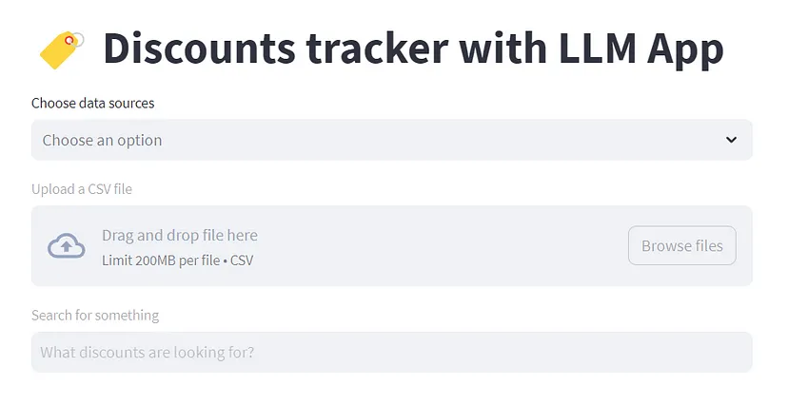

In this case, instead of cloning this Discounts app repository, we'll try to observe and learn how it uses LLM App with the Rainforest Prices API to give the desired results.a

In this app, we have two data sources:

* [Rainforest API for Amazon Prices](https://www.rainforestapi.com/)
* Discounts CSV with product and prices data

These two sources are used just to show how you can upload a CSV along with another data source. While you can use a similar approach with other APIs, even this showcase opens up considerable possibilities in E-Commerce applications

## 6.4.1. How the Project Works

The project accomplishes its tasks through a series of steps shared below. Make sure you give it a quick read before proceeding to the next step where we explore the repository.

**1 - Realtime Indexing:**

* Sourcing data: A script called mimics real-time data from external sources. It creates or updates a file named discounts.csv with random data. Alongside, a scheduled task (cron job) using runs every minute to fetch the latest data from Rainforest API. Crontab is a time-based job scheduler.
* Giving the option to choose particular data source(s): With the Streamlit UI provided, either select Rainforest API as a data source or upload a CSV through the UI file-uploader. It then maps each row into a jsonline schema for better managing large data sets. This format helps in managing large datasets by representing each row as a separate JSON object
* Chunking: The documents are divided into shorter sections for them to be converted into vector embeddings.
* Embedding of data source: These shorter sections are processed through the OpenAI API to generate embeddings.
* Real-time Vector Indexing: An index is created based on these embeddings to facilitate quick searching later on.

**2 - Query (Prompt) Embedding and Retrieval**

* Query Embeddinging: For any question asked by the user, an embedding is generated using the OpenAI API for embeddings, i.e. text-embedding-ada-002.
* Retrieving: The system compares the vector embedding of the query/prompt and the vector embedding of the data source to find the most relevant information.

**3 - Prompt Augmentation and Answer Generation**

* The query/prompt and the most relevant sections of data are packaged into a message within the token limit.
* Get Answer from GPT: This message is sent to gpt-3.5-turbo, which then provides an answer.

## 6.4.2. Repository Walkthrough

In this particular example, we'll dive a bit deeper to show you how this particular application was made so you can make one of your own.

### Link to the Project

* The repository being referred to can be found [here on GitHub](https://github.com/Boburmirzo/chatgpt-api-python-sales).
* If you have a good experience with open source, visiting the above link should enable you to seamlessly build a similar project.

### 

### Step by Step Process to Build the Application

A good way to understand the code here would be to read the Streamlit blog below which features the open source application developed by Bobur.

It's a friendly and easy to understand blog that also shows how the application interacts with users via an HTTP REST API and works in real-time, offering support for various data types like JSON Lines and Rainforest Product API.

LINK: [How to build a real-time LLM App | Official Streamlit Blog](https://blog.streamlit.io/build-a-real-time-llm-app-without-vector-databases-using-pathway/)

### Video Tutorial

Once you've read the blog above, check out this video tutorial by Bobur Umurzakov (Developer Advocate at Pathway) where he gives a quick walkthrough of the code and the open-source repository.

YouTube Video to be Embedded: <https://youtu.be/IxdeW_Ndi_8>

### **Key things to note**

* This app is modular; you can add new data sources or interfaces.
* You could scale it up to include more advanced features like additional data formats or APIs.
* Streamlit and Pathway's LLM App communicate over HTTP REST API, but they can also be integrated in other ways, such as file sharing or inter-process communication.

By following this guide, you'll create a versatile application capable of real-time interactions with users, providing them with valuable insights into Amazon discounts.

## 6.5. How to Run Examples

Congratulations for coming this far! 🎉

Let's say you want to go beyond the Amazon Discounts App and Dropbox Retrieval App. This module is to make it easy for you to build and run your applications using Examples on the [LLM App](https://github.com/pathwaycom/llm-app).

### What are Examples?

Popular open source frameworks often include an "examples" folder in their GitHub repositories, though it's not a mandatory thing.

The purpose of this folder is to provide practical, real-world demonstrations of how the software or code within the repository can be used. You can find the same on the [LLM App GitHub repo](https://github.com/pathwaycom/llm-app) too. Generally speaking, here are some key aspects of an "examples" folder in open source repositories:

* Demonstrations of the software's features.
* Educational examples to help new users.
* Various use case scenarios.
* Code snippets and templates for easy use.
* Examples for testing new updates.
* Community-contributed examples for diverse applications.

### Examples offered for LLM App

The LLM App official repository offers multiple possible use-cases under its [examples](https://github.com/pathwaycom/llm-app/tree/main/examples/pipelines) folder to illustrate various use-cases

Once you've **cloned the LLM App** repository and set up the **environment variables** (as per the steps mentioned on [this link](https://github.com/pathwaycom/llm-app#step-1-clone-the-repository)), you're all set to run the examples.

Below is a table that shares the types of examples you can explore.

| **Example Type** | **What It Does** | **What's Special** | **Good For** |
| --- | --- | --- | --- |
| contextless | Answers your questions without looking at any additional data. | Simplest example to try. Not RAG based. | Beginners to get started. |
| contextful | Uses extra documents in a folder to help answer questions. | Better answers by using more data. | More advanced, detailed answers. |
| contextful_s3 | Like "Contextful," but stores documents in S3 (a cloud storage service). | Good for handling a lot of data. | Businesses or advanced projects. |
| unstructured | Reads different types of files like PDFs, Word docs, etc. | Can handle many file formats and unstructured data. | Working with various file types. |
| local | Runs everything on your own machine without sending data out. | Keeps your data private. | Those concerned about data privacy. |
| unstructuredtosql | Takes data from different files and puts it in a SQL database. Then it uses SQL to answer questions. | Great for complex queries. | Advanced data manipulation and queries. |

### Simple Way to Run the Examples on LLM App

Considering you've done the steps before, here's a recommended, step-by-step process to run the examples easily:

**1 -** Open a terminal and navigate to the LLM App repository folder:

cd llm-app

**2 -** Choose Your Example. The examples are located in the [examples](https://github.com/pathwaycom/llm-app/tree/main/examples/pipelines) folder. Say you want to run the 'alert' example. You have two options here:

* **Option 1**: Run the centralized example runner. This allows you to quickly switch between different examples:

python run_examples.py alert

* **Option 2**: Navigate to the specific pipeline folder and run the example directly. This option is more focused and best if you know exactly which example you're interested in:

python examples/pipelines/contextful/app.py

That's it! 😄

By following these steps, you're not just running code; you're actively engaging with the LLM App’s rich feature set, which can include anything from real-time data syncing to model monitoring.

It's a step closer to implementing your LLM application that can have a meaningful impact. 💪